Pitch AI: Revolutionizing Presentations with Artificial Intelligence
Faisal Hossain Anik

Introduction
Pitch AI is an AI-powered tool used for generating professional presentation slides from simple text prompts. It is useful for saving time and effort, as it handles design, layout, and content automatically. You would need this AI if you are a student, educator, or professional who needs polished presentations quickly without any design skills.

Prompt
The following prompt was given to Pitch AI:
"Create a visually stunning 10-slide presentation about the solar system. Cover: overview of the solar system, the Sun, inner planets, outer planets, dwarf planets, moons, asteroids and comets, space exploration, fun facts, and future missions. Tone: educational and engaging. Audience: students."

Output
Pitch AI generated a complete 10-slide presentation titled "Solar System Wonders." The output included fully designed slides with high-quality space imagery, structured text content, and a consistent dark-themed visual style that complemented the subject matter. A sample slide from the presentation is shown below — the "Dwarf Planets" slide, which featured cards for Pluto (the former 9th planet), Eris (discovered in 2005 and larger than Pluto), and Haumea (a fast-spinning elongated dwarf planet), each paired with stunning astronomical visuals.

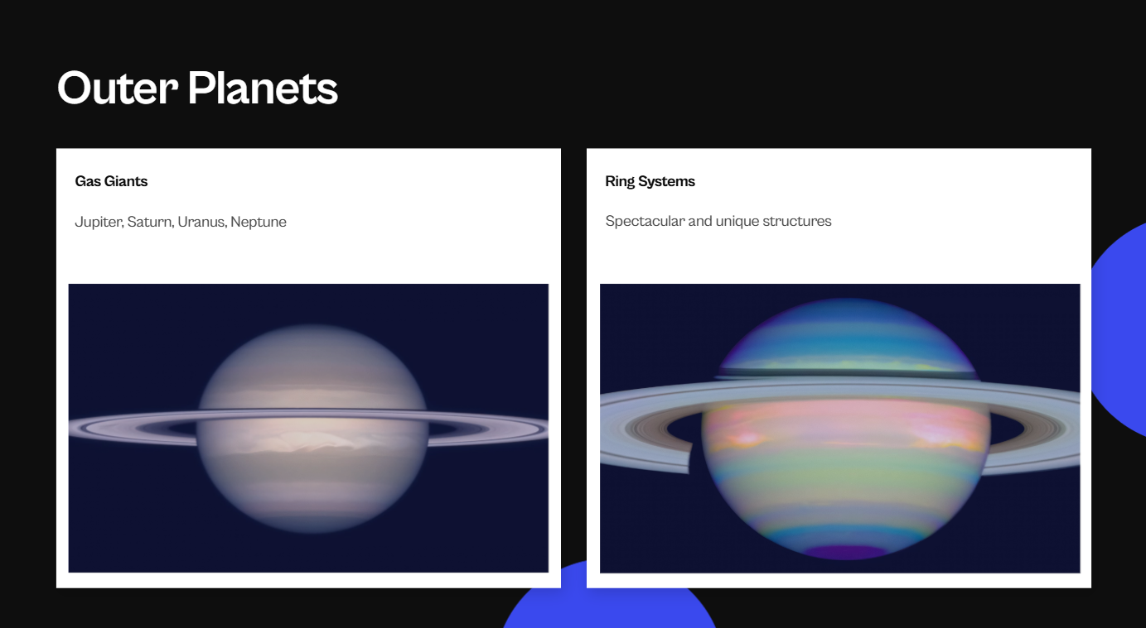
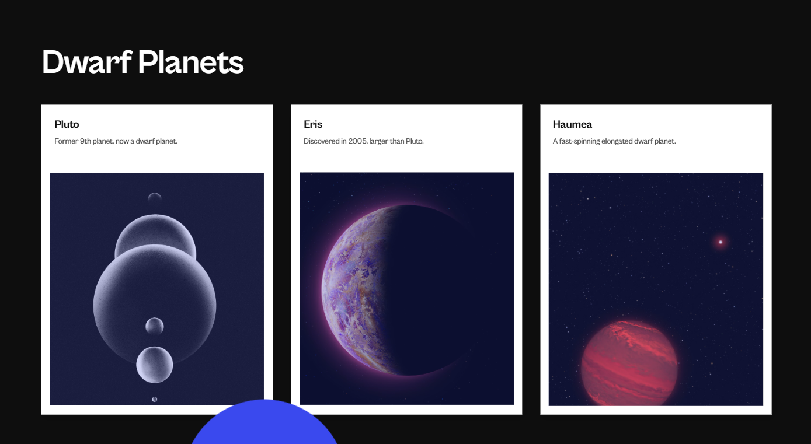

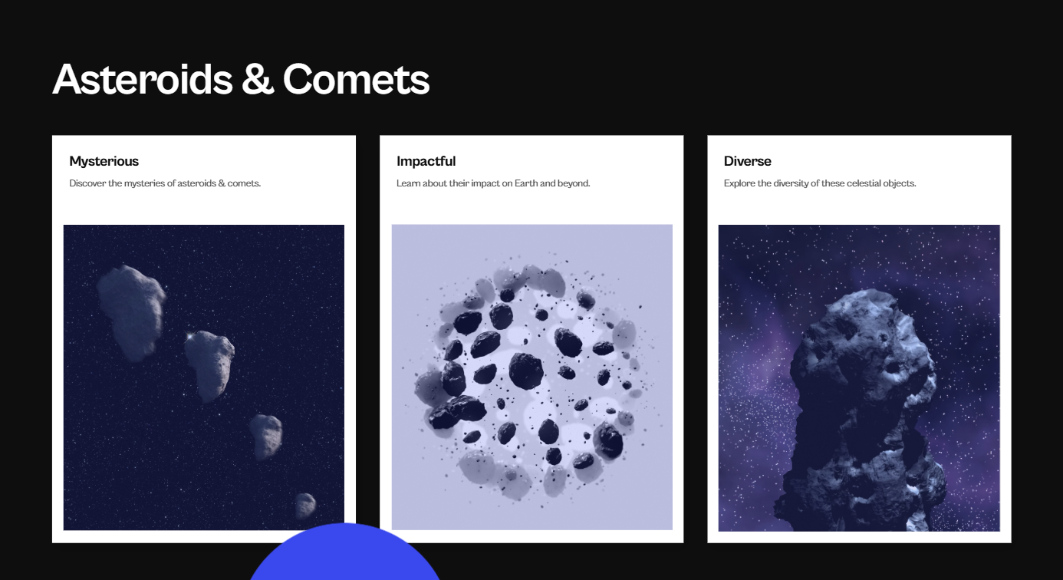

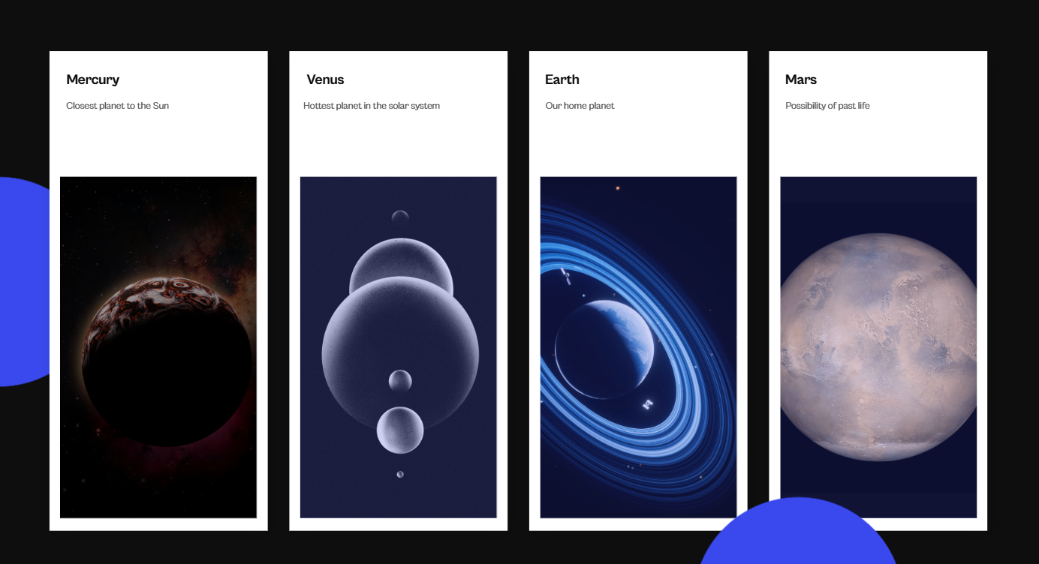

Describing the Output
The generated presentation was polished and ready to use with little to no editing. Each slide covered a specific topic from the prompt, with a cohesive dark background, white text, and vibrant astronomical images that made it visually appealing for students. The AI correctly interpreted the educational tone and produced content that was both informative and engaging.

Prompt Engineering
To get the best results from Pitch AI, the following prompt engineering strategies are recommended:
• Specify the exact number of slides: Telling the AI exactly how many slides you want (e.g., "10 slides") ensures it distributes content evenly and does not produce an oversized or undersized deck.
• List the topics explicitly: Providing a detailed list of topics (e.g., "the Sun, inner planets, outer planets, dwarf planets...") guides the AI to cover everything you need, reducing the chance of important content being missed.
• Define the tone clearly: Specifying the tone (e.g., "educational and engaging") helps the AI match the language style and formality to your use case, resulting in more appropriate content.
• Identify the target audience: Mentioning the audience (e.g., "students") allows the AI to calibrate complexity, vocabulary, and visual style accordingly.
• Use descriptive visual adjectives: Words like "visually stunning" or "professional" signal the AI to prioritize aesthetic quality in the design output.
• Iterate with refinements: After receiving the initial output, you can prompt the AI further with refinement instructions such as "make the intro slide more detailed" or "add more data to the space exploration slide" to progressively improve the deck.

Conclusion
Pitch AI is a mostly free AI-powered presentation tool, though outputs come with a watermark on the free plan. Compared to tools like PowerPoint or Google Slides, it saves significantly more time by automating design and content generation. While competitors like Beautiful.ai and Gamma offer more customization, Pitch AI is the better choice for users who prioritize speed and visual quality. For simple, quick, and professional presentations, it is hard to beat.

Note: This chapter was co-written with the assistance of Claude (claude.ai) by Anthropic. Claude was used to help draft, structure, and refine the written content of this chapter.

